Student
Professor
Course
Date
Gothic elements
Gothic elements have been used in this text to make mysterious happenings in the events, which invoke a lot of suspense, and terror to the reader, “A rose of Emily” is a perfect example where the author William Faulkner uses gothic elements that are expressed in the theme of lost love, murder, and death, poor parenting etc.
Emily who lived with her father was young when they arrived at the town, her father was rich people in the town respected her because of her family status; the father had restricted her from mingling with men. The author describes in the story as a lonely person “she looked bloated, like a body submerged in motionless water and of that pallid hue. Her eyes lost in the fatty ridges of her face, looked like two small pieces of coal pressed into a lump of dough” she is expressed as a living dead. The people of the town started to hear a certain smell that was coming from her house. The bad smell was believed to be the corpse of his father (Gioia, Dana, and Gwynn, 34).
In the story, Emily comes from an aristocratic family, they were rich and the townsmen respected her, the author represents gothic when Emily goes to buy arsenic to a shop, being a person of the social class, she should have explained the uses of the poison. She doesn’t want to follow the law and state the reasons for using the arsenic, the Way Emily describes the poison shows that her intention is not good; this is a short conversation between the druggist and Emily.
“I want poison,” she said to the druggist
“Yes, miss Emily .what kind? For rats and such? I’d recom –
“I want the best u have I don’t care what kind”
“They can kill anything to up to an elephant”
“Arsenic,” Miss Emily said “is that a good one”
Because of her pride, she disrupts the druggist three times in the short conversation; she also shows the determination to buy the poison which creates suspense that she will use the poison for a bad intention, the town people also think that she will use the poison to kill herself.
Emily had stayed for long without being married, her father used to deter men from approaching her. She was so lonely after his father’s death, but homer arrived, he had just won contracts to build the road in the town. The townsmen could see homer and Emily together they would go for outs, peoples suggested that now she had found her partner and she would get married, but the gothic happens when she decides to use the arsenic to kill Homer. Later after she dies people break into her room and finds homer corps on the bed, she killed homer to prevent him from leaving her forever. They also find the strands of her hair next to the corpse, suggesting that she was sleeping will dead people (Gioia, Dana, and Gwynn, 34).
The story “A rose of Emily” practically gothic, the theme of death presented in the story creates a lot of tragedy. In the case of Emily death the author shows how the townspeople attended the funeral “When Miss Emily died, our whole town went to her funeral: the men through a sort of respectful affection for a fallen monument, the women mostly out of curiosity to see the inside of her house, which no one saves an old man-servant – a combined gardener and cook—had seen in at the least ten years. Since Emily lived a lonely life, she had no friends from the town .when she died people in the town were curious to know which kind of life she leads. As they opened one of her secretive rooms the town’s people found the corpse of Homer Barron, she had killed her .hey found the fact that Homer didn’t leave Emily but died in her house. The town’s people also found strands on the pillow next to the corpse which suggested that she had been sleeping with the corpse. The townspeople could not believe their eyes .they could not imagine someone of Emily social class could leave such a life (Harris, 5).
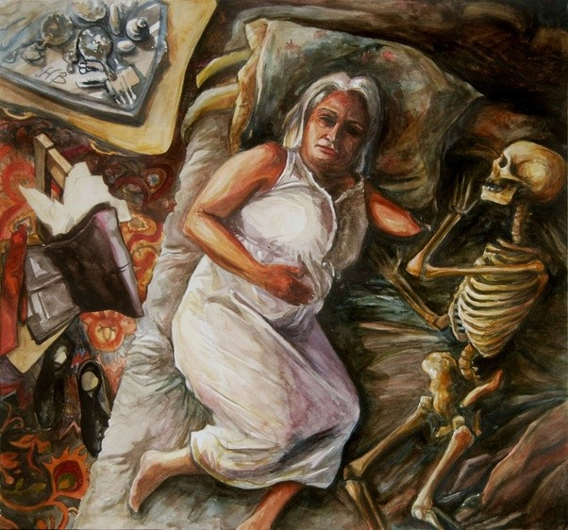
The figure illustrates how Emily used to sleep with a corpse
Another death situation in the story is when Emily father dies “when the father died, it got about that the house was all left to her, and in a way people were glad, and At last, they could pity Miss Emily. Being left alone, and a pauper, she had become humanized. Now she too would know the old thrills and the old despair of a penny more or less” Emily father controlled her social life, she even drove away young men who approached Emily for marriage. This death tragedy is gothic; the town’s people pity Miss Emily because she has been left lonely.
In the case of her father’s death the author shows how Emily behaved, she acted like nothing had happened .she even went to an extent of keeping him for three days without burying him “The day after his death all the ladies prepared to call at the house and offer condolence and aid, as is our custom Miss Emily met them at the door dressed as usual and with no trace of grief on her face. She told them that her father was not dead. She did that for three days, with the ministers calling in her, and the doctors trying to persuade her to them dispose of her body, just about there were about to resort to the law and force, she broke down and they buried her father quickly”. The gothic element in this situations shows that Emily does not fear to leave with the dead in her house (Harris, 5).
Another case of death is when Emily decides to use the arsenic she bought to kill her lover. Miss Emily was growing old, she was desperate to get married, she met her lover Homer Barron, who takes her for outs, she thinks that he is going to leave her, and decides to kill him so as to keep him forever that the author shows how the townspeople were astonished to find what Emily was keeping on her house.” For long a while, we just stood there looking down at the profound and fleshless grin. The body had once lain in the attitude of an embrace but now the long sleep that outlasts love, that conquers even the grimace of love, had cuckolded him. What was left of, him, rotted beneath what was left of the nightshirt, had come inextricably from the bed in which he lay; and upon him and upon the pillow beside him lay that even coating of the patient and biding dust”. The decaying nature of the corpse by the author shows the gothic element in the story (Prose, Francine, and Bailey, 5).
Another situation of death that is expressed by the other is the death of the former mayor of the town Colonel Sartoris. When Miss Emily was requested to pay taxes by the new leadership of the town, she told them that the former mayor had relieved them from paying taxes because her father had contributed much to the town. “Colonel Sartoris invented and a tale to the effects that Miss Emily father had loaned money to the town.” The former mayor had died a decade ago. The series of deaths in the short story is frightening to the readers (Harris, 5).
The author also portrays gothic in the way he presents in the description of Emily’s house. when Emily and her family they were rich and build a nice and a big estate, times have changed and now the estate is ugly and desolated, the author describes the house as dump, large and empty and full of corners to hide secrets the use of such as “smelled of dust and disuse” and “a closed, dank smell, shows that the place was neglected and decay was setting in.
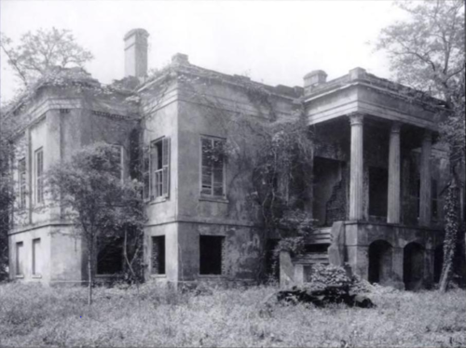
An image showing an ugly estate that was neglected this is a perfect image to represent Emily house.
Miss Emily uses the word “negro” this is a word used to show African American people; she uses it to show racism and slavery, this is not quite right in the current society we should not discriminate people according to their, race, religion or either political affiliations. The use of this name describes fear to the readers; it was difficult for black people to live in the town because of discrimination. Using the theme of lost love, we can see the how the father used to control her social life, he could not allow any men in the town, her father thought that there was no man enough for her, he drove them away, and this made her develop a lonely character. She could stay at her house for even three days, in this situation we can Emily leaved with fear, because of poor parenting she got from her father. It is expected that parents should be happy when their children marry but in this story, gives the reader a lot fear on how to live with such a parent who controls her life (Gioia, Dana, and Gwynn, 34).
In the story the author shows us that Emily stays with her dad, it means she was raised by her dad since she was young, Being raised by both parents maybe could have helped her grow and be able to interact with other people in the in the town. Though it is not the wish of anyone to be raised by one parent the case of Emily being raised by her father raises creates a lot of fear to the reader. If maybe she had a mother she would not have been lonely, she would have developed communications skills to interact within the rest of the town, she could also have learned to forget the past and be able to move on with life. She would have learned to love his boyfriend Homer and she could have married her instead of killing him (Romdhani, Mourad, 12).

References
Gioia, Dana, and R. S. Gwynn. The Art of the Short Story. Pearson Longman, 2016.
Harris, A. "In Search of Dead Time: Faulkner's" A Rose for Emily"." KronoScope 7.2 (2017): 169-183.
Prose, Francine, and Tom Bailey, eds. On writing short stories. Oxford University Press, USA,
Romdhani, Mourad. "Miss Emily Grierson’s Psychopathy in William Faulkner’s “A Rose for Emily”: Overt Disorder, Covert Order." International Journal of Humanities and Cultural Studies (IJHCS)​ ISSN 2356-5926 3.2 (2016): 1513-1524.2017

